AGRICHAIN
Solution Blueprint, Technical Architecture & MVP Roadmap

First version · Cashew corridor
Côte d'Ivoire to a European buyer
17 October 2026

Contents
Decisions locked for the MVP
Solution blueprint
People in the pilot
Path of a lot
What the pilot has to prove
Domain model
Records
Event types in the MVP
Canonical event
Claims and bands
Rejected writes and opened alerts
Alerts survive a merge
Technical architecture
Stack
Key versions
Write path
Read path
Database rules
Authorization
Kernel and configuration
MVP roadmap
Phase 1 — Parcel and harvest
Phase 2 — Named merges
Phase 3 — Handoff, load, and process
Phase 4 — Pack and claim
Phase 5 — Authority and audit
After the MVP
Out of scope
How this stays honest

This is the build document for the first version of agriChain. Product rules stay in system.md and design-laws.md. This document says how the first corridor is built, on what, and in what order.
The MVP is one cashew corridor with a small set of organizations who accept a single operator’s database, provided every handoff is signed and hash-chained. A shared ledger is a later move, made when a second operator will not accept that database.

Decisions locked for the MVP
Decision | Choice
Who may disagree with the database | Coop, plant, buyer, and origin authority accept one operator. Each event is signed by the organization that witnessed it. Any of them can recompute the hash chain.
Who writes a harvest | A coop clerk, in a web app, naming the grower and the parcel. Growers are records. They do not need an account in the MVP.
What a stranger sees | A public claim page: commodity, biological origin country, process countries, claim status, packing expiry, and a quantity band. Exact weight, coordinates, and document hashes stay behind a role.
How a lot changes hands | A transfer signed by the custodian and an accept signed by the receiver. Custody moves on the accept. A transfer nobody accepts opens an alert.
Where private data lives | The same Postgres database. Narrow views are API projections and database privileges, not a second store.
What “ledger” means here | An append-only event log. No token, no public chain, no permissioned chain in the MVP.
Offline capture at the farm gate is not in the MVP. Add it only if the pilot coop cannot record the harvest at a connected buying point.

Solution blueprint
agriChain keeps a lot of cashew honest from a parcel in Côte d’Ivoire to a European buyer. It answers three questions: what this is, where it grew, and which country kept the value of each step.

People in the pilot
Who | Account | What they write or read
Grower | None | Named on a harvest. No login.
Coop clerk | Yes | Registers parcels, writes harvests, merges lots, transfers the lot to the plant, records the load that leaves the country.
Plant clerk | Yes | Accepts custody of a lot, records processing, loss, and outputs, packs and inspects.
Buyer | Yes | Reads the claim, the last inspection, and a quantity band, for lots transferred to it.
Origin authority | Yes | Reads volumes leaving Côte d’Ivoire and where processing happened.
Auditor | Yes, granted by the operator | Opens the full path when an alert exists.
Public | None | Opens a claim page from a code on the bag.
A broker is an organization that can enroll and sign events it witnessed. The MVP does not need one on the first path. The data model still has a place for that organization, because the middle of the chain is where the record has to exist.

Path of a lot
The coop clerk signs until the lot leaves the country, ending with a transfer to the plant. The plant clerk signs the accept that takes custody, then the processing. The claim is calculated. Biological origin stays the country of harvest. The plant’s country is added beside it.
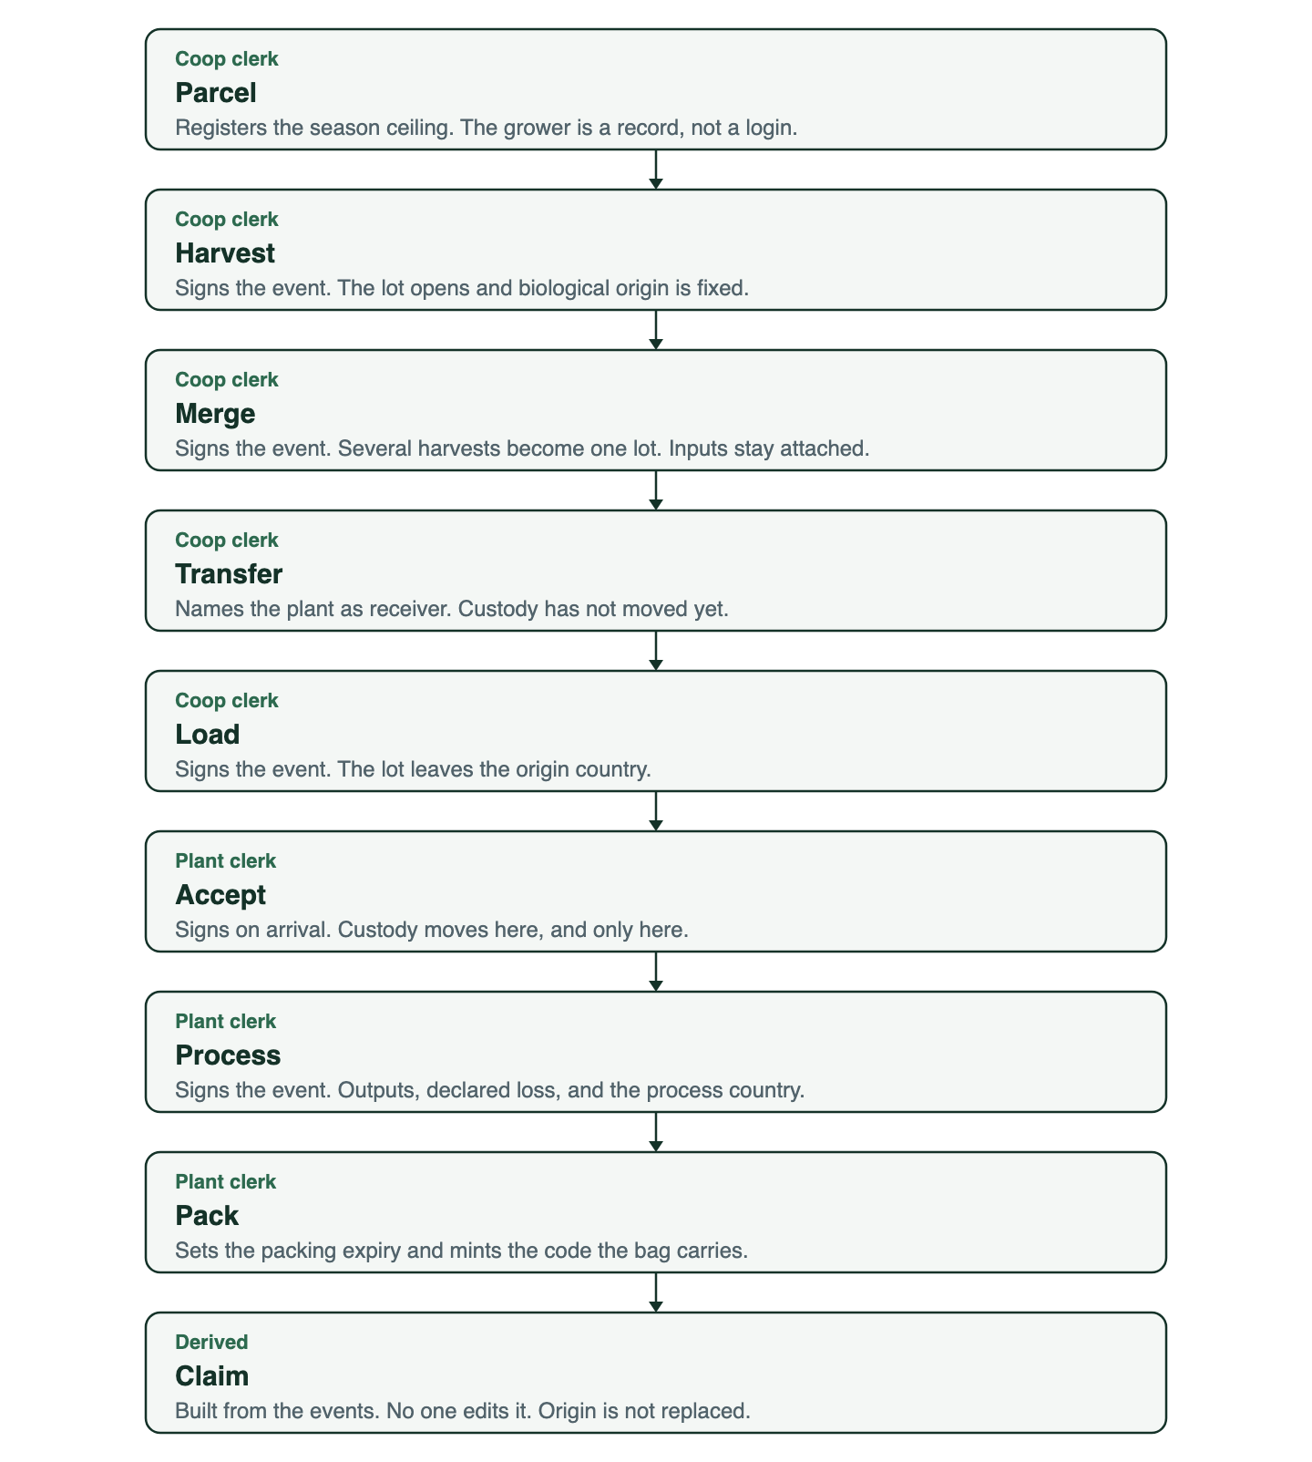
Parcel, harvest, merge, transfer, load, accept, process, pack, and claim, with the person who signs each step
The same lot is narrower for a stranger than it is for the coop.
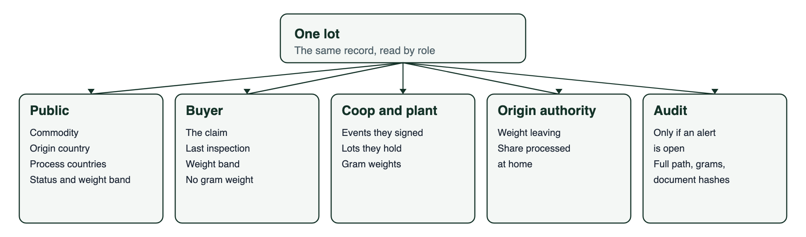
The same lot, read by the public, the buyer, the holders, the origin authority, and an auditor

What the pilot has to prove
- A harvest names a parcel, a season, a grower, and a weight.
- Several harvests become one lot, and every input stays attached.
- Every change of hands has two signatures: the side letting go, and the side taking it.
- The plant cannot ship more kernel than the raw nuts support. Loss is declared. Shells are either an output or part of that loss.
- The public claim says the nuts grew in Côte d’Ivoire even when they were cracked somewhere else.
- An over-yield, a short mass balance, a relabel that moves the date, or a handoff nobody accepted opens an alert and still keeps the event.
- An alert on a harvest lot is still visible on the claim of the lot it was merged into.
- The origin authority can see whether the cracking happened at home or abroad.
Settlement, payments, and an investigation graph are not part of this proof.

Domain model
Quantities are integers in grams. There are no floating-point weights.

Records
The six records in system.md map to tables as follows.
Record | Table | Notes
Actor | actors, memberships | A person or an organization. A clerk belongs to one organization.
Place | places | Parcel, plant, port, or vessel. A parcel holds a season yield ceiling in grams.
Lot | lots | One commodity. biological_origin_country is insert-only. holder_org_id is the current custodian. profile_version records the configuration the lot was judged under.
Event | events | Append-only. The lot stores head_event_id.
Claim | claims | Rebuilt in the same transaction as the event that changed it.
Alert | alerts | Opened by a check. Never deletes the event.
Growers and parcels can exist before any login. A parcel stores country, area, commodity, season, and a manual yield ceiling. For the MVP that ceiling is entered by the coop from a published figure for the area. It is the number the harvest is judged against.
lots.holder_org_id is a projection, not a second source of truth. It is written in the same transaction as the accept event that moved custody, and the write path reads it instead of replaying the chain on every request. An auditor can rebuild it from the events alone.
lots.profile_version is set when the lot is created and never changes. A band, a tolerance, or a claim field can be edited in configuration later, so without this a published claim would silently change meaning. The claim is always recomputed against the version the lot carries.

Event types in the MVP
Type | Who signs | What it does
harvest | Coop | Creates a lot. Sets biological origin. Names parcel, grower, season, weight. Custody starts with the signer.
merge | Current custodian | Creates an output lot. Consumes each input lot. Output weight equals the sum of inputs. Commits to each input lot’s head hash.
consume | Written by the server, in the same transaction as merge or process | Closes an input lot and points at the output. Never submitted by a client, so it has no capability of its own.
transfer | Current custodian | Names the receiving organization and the reason. Custody does not move yet.
accept | Receiving organization | Takes custody. Moves holder_org_id. The only event that changes the custodian.
load | Custodian | Records carrier, origin port, destination port, and the country the lot is leaving.
process | Plant | Consumes the input lot. Creates output lots. Declares additives and loss. Records the process country.
pack | Plant | Sets the packing expiry and mints the public code the bag carries. Runs once per lot.
inspect | Lab or plant | Stores a pass or fail and the hash of the report. Does not store the file.
relabel | Custodian | Proposes a new label, code, or expiry. The claim keeps the packing expiry from pack.
split, vessel call, and release exist as names in the product model. They are not required to finish the cashew MVP. A voyage with an extra port is the first event type added when a real shipment needs it.
inspect stays in the kernel rather than in a module. The buyer view and the Phase 5 exit check both depend on it, and a pass or fail with a report hash needs no commodity knowledge. What the Credence module adds later is claim gating, the rule that a species or a honey grade may not be published without a passing inspection. That gate is off for cashew.
In the pilot the plant signs inspect. No lab is enrolled on the first path, which is why the people table has no lab row. Granting write:inspect to a lab is a row, not a schema change.

Canonical event
Every event is a JSON object serialized by RFC 8785, the JSON Canonicalization Scheme, and signed as UTF-8 bytes:
{
"id": "uuid",
"lot_id": "uuid",
"type": "harvest",
"prev_hash": "hex or null for the first event",
"actor_id": "uuid of the signing organization",
"key_id": "uuid of the signing key version",
"observed_at": "RFC 3339 instant the signer witnessed this",
"payload": {}
}
RFC 8785 is named rather than described, because “a fixed field order” is not something a second party can reimplement. A coop, a buyer, and an auditor have to produce the same bytes from the same event or none of them can check a signature.
event_hash is SHA-256 of those canonical bytes. The organization signs event_hash with Ed25519, and the stored row keeps event_hash, signature, and key_id beside the event. The lot’s chain links prev_hash to the previous event’s event_hash. The first event on a lot uses prev_hash: null, and only one such event is allowed.
observed_at is signed by the clerk and is the time the thing happened. The server’s received_at is stored outside the signature and is the time the record arrived. The two are different facts, and expiry, season, and the transfer window all depend on the first one. The server rejects an observed_at in the future or older than a window the profile sets.
The server rejects a body whose signature does not match the public key of that key_id, whose key_id does not belong to the signing organization, whose prev_hash is not the current head, or whose id has already been stored. A retry of the same id returns the stored event.
A merged lot’s first event is merge with prev_hash: null, so the per-lot chains do not link across the merge on their own. The merge payload therefore commits to the event_hash of each input lot’s head. Lineage is then hash-committed in both directions: the consume on the input points forward, and the hash in the merge payload points back.

Claims and bands
A claim is derived. Users do not edit it.
Field | Rule
Commodity | Copied from the harvest.
Biological origin | Copied from the harvest. No later event writes this field.
Process countries | Appended by each process event, in order.
Status | clear or alert. An alert inherited from a consumed input lot also shows alert.
Packing expiry | Set by the pack event. A relabel does not replace it.
Quantity band | A bucket from the commodity profile, not the gram value. The cashew profile uses under 1 t, 1–5 t, 5–20 t, and 20 t and over.
The buyer and the public page receive the band. The coop, the plant, and an opened audit receive grams.

Rejected writes and opened alerts
Two different outcomes, and the docs used to confuse them. A write is rejected when what it claims is impossible, because there is nothing true to record. A write is stored with an alert when what it claims is merely implausible, because the record is the signal. The design law is “Implausible before criminal”, not “implausible is refused”.
Rejected. Nothing is stored.
Check | Rule
Over-emission | Outputs plus declared loss exceed the input. More came out than went in, which is not a thing that happened.
Origin write | Any attempt to update biological_origin_country fails the transaction.
Wrong custodian | The signing organization is not the current holder.
Double pack | A second pack on a lot that already has a packing expiry.
Stored, and the claim status becomes alert.
Check | Rule
Yield ceiling | Sum of harvests for that parcel and season is greater than the ceiling.
Merge shortfall | Output grams fall short of the sum of input grams by more than the profile tolerance.
Process shortfall | Outputs plus declared loss fall short of the input by more than the profile tolerance. Additives are inputs.
Unaccepted transfer | A transfer with no matching accept after the window the profile sets.
Relabel | The new expiry is later than the packing expiry, or the public code changes.
Inherited alert | An input lot had an open alert when it was consumed.
The tolerance is a profile value in grams or basis points, not a constant in the handler. Cashew drying loses weight between the farm gate and the intake scale, and a corridor that weighs wet nuts needs a different number than one that weighs dry.

Alerts survive a merge
An alert is opened on a lot. A merge consumes that lot and creates a new one, so without a rule the status does not follow the goods: a clean output lot would carry no sign of an over-ceiling harvest, and because an audit may only be opened on an alerted lot, the trail would close at the same moment. Laundering a bad harvest would be one merge.
- The output of a merge or a process inherits an open alert from any input lot, stored as its own alert row referencing the source lot and the source alert.
- An audit may be opened on a lot that has an alert of its own, or that is an ancestor or a descendant of an alerted lot. The lineage is walked through consume events.
- Closing the source alert does not rewrite the inherited row. It records the resolution beside it.

Technical architecture
One web service and one Postgres database. The browser signs. The API checks and stores. Views are queries.
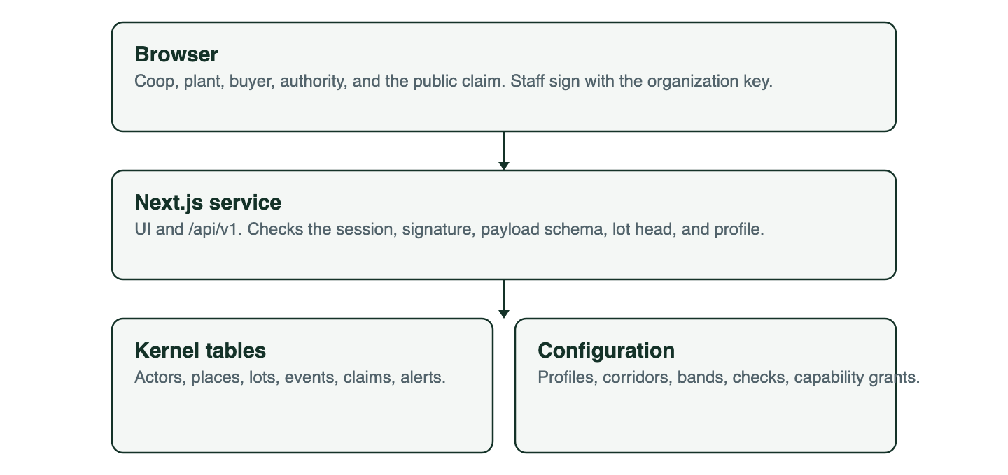
Browser, API, kernel tables, and configuration
There is no worker, cache, or object store in the MVP. Document files stay with the party who holds them. The event stores the SHA-256 of the file.

Stack
Layer | Choice
Language | TypeScript
Service | Next.js (App Router). The UI and the HTTP API ship as one service.
API | Versioned route handlers under /api/v1. The UI is a client of that API.
Database | Postgres 16
Schema and queries | SQL migrations. Drizzle for queries.
Validation | Zod, one schema per event type
Auth | Auth.js session cookies for staff. Organization and role live in memberships, not in the auth provider.
Signatures | Ed25519 in the browser via WebCrypto. Server stores public keys only, one row per key version.
Canonical form | RFC 8785 (JSON Canonicalization Scheme)
Hash | SHA-256 over the canonical bytes
Hosting | One region, one service, managed Postgres, daily backups
The private key is generated in the browser when an organization enrolls. It is encrypted with a passphrase the organization keeps. The server may store the ciphertext so a new clerk machine can download it. The server cannot decrypt it. Signing happens in the browser after the passphrase is entered.

Key versions
One key per organization with no version is a trap. Clerks share the passphrase, so a clerk who leaves still holds it, and the only remedy is a new key. If events do not say which key signed them, replacing the key makes every past signature unverifiable, and the custody property this MVP owes is gone.
- org_keys holds one row per key version: organization, public key, created_at, revoked_at, and the reason.
- Every event stores key_id. Verification uses the key named by the event, not the organization’s current key.
- A revoked key still verifies events it signed before revoked_at. It cannot sign new ones.
- Rotation is enrollment again: the browser generates the next version, the operator records it, and the old row gets a revoked_at.
- An event whose observed_at falls after its key’s revoked_at is rejected.
Nothing here needs a new event type. Rotation is rows in org_keys, which is why it belongs in the MVP even though no pilot organization will rotate during it.

Write path
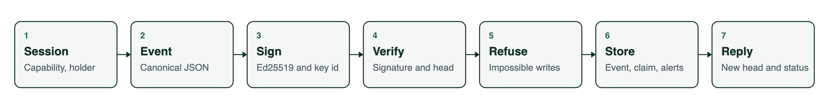
Session, event, signature, verification, refusal, store, and reply
- The clerk’s session is a member of the organization, the organization holds the capability for that event type, and it is the lot’s current holder.
- The browser builds the canonical event using the lot’s current head hash, its own key_id, and observed_at.
- The browser signs event_hash and posts the event.
- The API checks the session, the capability, the holder, the signature against that key_id, the payload schema, and the head.
- The API runs the rejecting checks. A failure here returns an error and stores nothing.
- One database transaction inserts the event, moves the head, writes any consume events, moves holder_org_id on an accept, rebuilds the claim against the lot’s profile_version, and inserts alerts, including any inherited from a consumed input.
- The response is the new head and the claim status.
Two clerks racing on the same lot: the second insert fails the unique constraint on (lot_id, prev_hash). The client reloads the head and asks the clerk to submit again.

Read path
Route | Caller | Returns
GET /api/v1/claims/:code | Public | Claim projection and quantity band.
GET /api/v1/lots/:id | Holder organization | Lots they signed or currently hold, with gram weights.
GET /api/v1/lots/:id/claim | Buyer the lot was transferred to | The claim, the band, and the last inspection with its report hash.
GET /api/v1/transfers/incoming | Receiving organization | Transfers awaiting an accept.
GET /api/v1/authority/retention?country=&season= | Origin authority for that country | Weight leaving, and the share of process events in that country. Aggregates only, never a lot row.
GET /api/v1/lots/:id/audit | Auditor, when the lot has an open alert or is in the lineage of an alerted lot | Full events, facility ids, gram weights, document hashes.
The audit read is written to an audit_opens row: who, when, and which lot.

Database rules
- The application role may INSERT into events and may not UPDATE or DELETE them.
- A trigger rejects updates to lots.biological_origin_country.
- events.id is unique.
- (lot_id, prev_hash) is unique, which serializes two clerks racing on the same head.
- A partial unique index on lot_id where prev_hash is null allows exactly one first event per lot. A plain composite unique does not do this, because Postgres treats each null as distinct and would let a lot have many first events.
- A trigger rejects updates to lots.profile_version.
- claims is updated only by the transaction that inserted the event.

Authorization
Role | Harvest and merge | Process and pack | Transfer and accept | Read grams | Read claim | Open audit
Coop clerk | Own lots | No | Both, on lots it holds | Own lots | Yes | No
Plant clerk | No | Lots the plant holds | Both, on lots it holds | Those lots | Yes | No
Buyer | No | No | Accept only | No | Lots transferred to it, plus last inspection | No
Origin authority | No | No | No | Country aggregates only | No | No
Auditor | No | No | No | Lots in an alerted lineage | Yes | Yes
A clerk can sign only with a key of their own organization, and only for a lot that organization currently holds. Two events are exceptions: harvest creates the lot, and accept is by definition signed by an organization that does not hold the lot yet.
The origin authority reads aggregates and nothing else. It has no claim column above, because a claim is about one lot and this reader is never given one.
That table is the cashew seed, not the authorization model. A profile grants capabilities to an organization kind, and the API asks whether the organization holds the capability:
write:harvest, write:merge, write:transfer, write:accept, write:load, write:process, write:pack, write:inspect, write:relabel, read:grams, read:claim, read:aggregates, open:audit.
consume has no capability. It is written by the server inside the merge and process transactions and is never accepted from a client. A lab or a port agent is a new grant, not a new column.

Kernel and configuration
Lots, events, and claims stay generic. Cashew settings live in seed data: profile, corridor, bands, merge policy, claim fields, enabled checks, and capability grants. The harvest handler does not contain a commodity name or an origin country. A later concern adds a module and rows, as set out in qa-modularity.md.
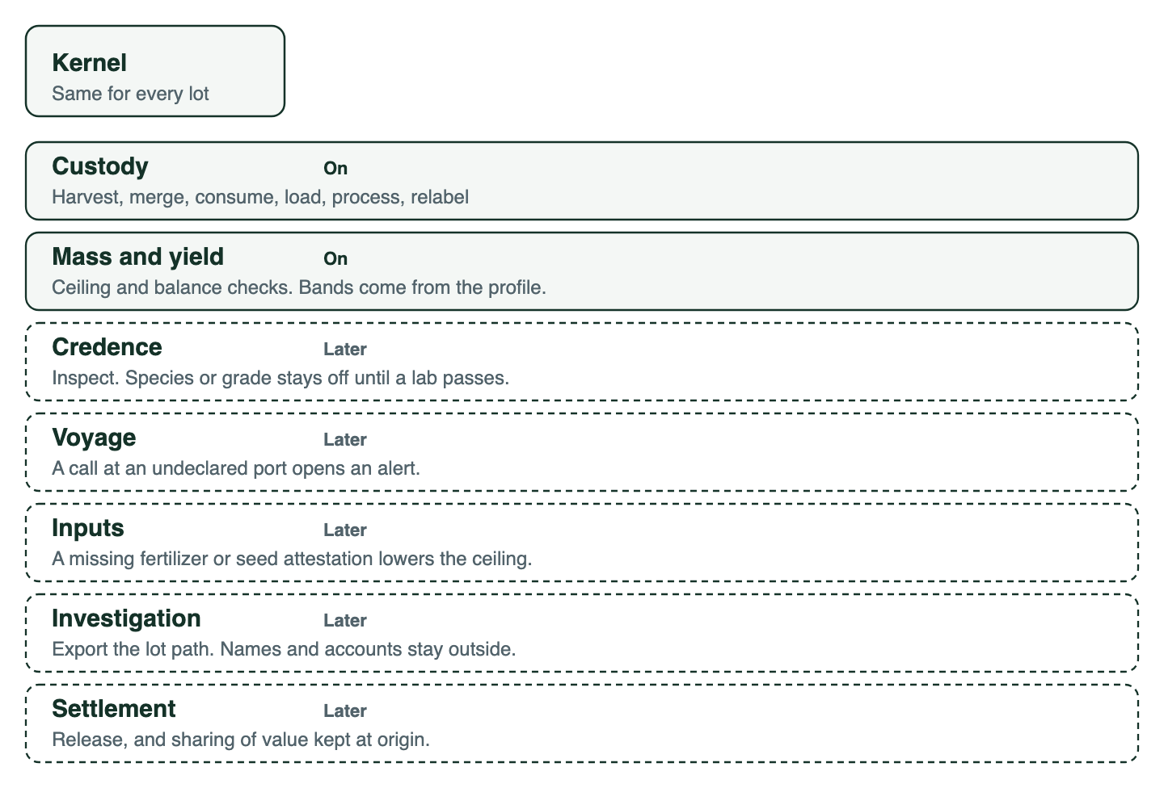
Kernel, and the modules that are on for cashew or left for later

MVP roadmap
Phases are sequential. A phase is done when its exit checks pass, not when the screens exist. Dates wait until a pilot coop and a plant are named.

Phase 1 — Parcel and harvest
Enroll a coop organization, register a parcel with a ceiling, and record a harvest signed in the browser.
Exit checks:
- A harvest from an unknown key is rejected.
- A second harvest that pushes the parcel over its ceiling is stored, and the lot’s claim is alert.
- biological_origin_country cannot be updated.
- The grower has no user account.
- The harvest path reads the cashew profile from configuration. It does not hard-code the commodity or the origin country.
- The harvest handler does not contain the strings cashew or Côte d'Ivoire.
- An enrolling organization cannot set its own kind. The kind is recorded by the operator, and an organization awaiting approval can sign nothing. Self-declaring as an origin authority or an auditor would otherwise be a read-privilege escalation.
- Two events signed by two key versions of the same organization both verify.

Phase 2 — Named merges
A clerk merges several harvest lots into one intake lot.
Exit checks:
- Every input lot has a consume event pointing at the output.
- A consumed lot cannot be merged again.
- Output grams above the sum of inputs is rejected. A shortfall beyond the profile tolerance is stored with an alert.
- The merge payload holds the head hash of every input lot, and an auditor can verify the lineage from the hashes alone.
- The output lot’s biological origin is copied from the inputs.
- An over-ceiling harvest lot merged into a clean lot leaves the output claim at alert, naming the source lot.
- The cashew profile rejects a mixed-origin merge. The test fixture uses Côte d’Ivoire. The merge code does not.

Phase 3 — Handoff, load, and process
Move custody to the plant with two signatures, record the lot leaving the country, and record the plant turning raw nuts into outputs plus a declared loss.
Exit checks:
- A transfer does not move custody. The coop is still the holder until the plant signs the accept.
- Only the named receiving organization can accept. Another organization’s accept is rejected.
- A transfer left unaccepted past the profile window opens an alert, and the lot is still held by the sender.
- The process country is stored beside biological origin. The pilot plant is abroad. A profile may process at home.
- Outputs plus loss above the input is rejected. A shortfall beyond the profile tolerance is stored with an alert.
- The plant cannot process a lot it does not hold, and could not hold it without an accept.

Phase 4 — Pack and claim
Set the packing expiry, mint the public code, and publish the derived claim.
Exit checks:
- pack sets the packing expiry and the public code. A second pack on the same lot is rejected.
- The public route returns commodity, origin, process countries, status, packing expiry, and a quantity band.
- The public route does not return grams, parcel coordinates, grower name, or document hashes.
- A relabel with a later expiry leaves the packing expiry on the claim and opens an alert.
- Editing a band in configuration does not change the claim of a lot already packed, because the claim is rebuilt against the lot’s profile_version.

Phase 5 — Authority and audit
This is the end of the MVP.
Exit checks:
- The origin-authority page shows weight leaving Côte d’Ivoire and the share of process events that happened there, as aggregates. No lot row and no single-lot weight appears on it.
- An auditor can open a lot only when it has an alert or sits in the lineage of an alerted lot, and the open is logged.
- An auditor can walk from an alerted harvest lot to the packed lot it ended up in.
- A buyer sees the claim, the last inspection result with its report hash, and the band, and only for lots transferred to that buyer.

After the MVP
In this order, and only when the pilot asks for them:
- Fertilizer or seed attestation that lowers a parcel ceiling when the attestation is missing.
- Vessel calls, so an undeclared port opens an alert.
- An export bundle for an external investigation graph: lot path, hashes, and organization ids. No KYC dossier in this database.
- Honey as a second commodity, where the fraud is content and a price premium.
- Fish only with a lab attestation required before a species claim.
- Settlement and retained-value sharing.
- An offline client, if buying points have no signal.
- A permissioned ledger for the hash chain, if a second operator refuses this database. The event JSON stays the same so the log can move.

Out of scope
- A token, a coin, or tokenized inventory.
- Full KYC, crew identities, and beneficial-ownership graphs.
- Public prices and public parcel coordinates.
- A grantor or donor portal.
- A model that writes events or invents an origin.
- Storing scans of shipping documents. Hashes only.
- Multi-region deployment and a mobile app.

How this stays honest
The operator can refuse to publish, and can go offline. The operator cannot silently rewrite a history that other parties have already verified, because those parties hold the signatures and the hashes. That is the custody property this MVP owes. It is not a claim that a cartel is inside the database. When an alert fires, the trail leaves this system and goes to people who investigate companies and accounts.

